Bid Pack
Attachment 2: How to bid including evaluation criteria

«Insert Procurement Title»
Reference: «Insert Event id»

a ‘call-off further competition’ in relation to
«Insert Lot id» «Insert Lot Name»
«Insert Commercial Agreement name» («Insert Commercial Agreement id»)

Buyer
«Insert Name of Buyer»

Contents

How to make your bid 3
Questions, weightings and evaluation criteria 5
How to complete your 4. Price Schedule 8
Award Criteria 9
Award process - What you need to do 9
Award process - What we will do 9
Compliance Check 9
Technical Evaluation 9
Commercial Evaluation 10
Final Score 10
Presentations 10
Award 10
Marking Scheme 11
Evaluation 12
Technical Evaluation 12
Commercial Evaluation 12
Final Decision to Award 14
Further Information 14

How to make your bid
Your bid must be made by the organisation that will be responsible for providing the deliverables if your bid is successful.
Remember to:
- Decline this Bid Pack if you do not wish to submit a response. If you Decline please provide a reason for doing so
- Enter your bid into the Government Commercial Agency's e-Sourcing Suite. We will only accept bids that we receive through the Government Commercial Agency's e-Sourcing Suite
- Submit your bid in good time and before the bid submission deadline.
- Your bid response should be attached to the procurement event in the Government Commercial Agency's e-Sourcing Suite
- Upload only those documents we have asked for in line with the requirements specified – any other supporting evidence, certificates for example, may be requested separately by us
- Where multiple documents are required they can only be submitted within a single compressed file format – .zip files is the only acceptable compressed file format
- Make sure you answer every question
- Each question must be answered in its own right. You must not answer any of the questions by cross referencing other questions or other materials e.g. reports located on your website
- Check for messages in the Government Commercial Agency's e-Sourcing Suite throughout the competition
- Press the Submit Response button when your bid is ready, otherwise we will not be able to see it.
- If you are unsure, ask questions before the Bid Clarification Deadline passes (see ‘Timelines for the competition’ in document 1. About the procurement)
Key information to be included in your response is as follows:
Please copy the following sections called ‘affirmations’; ‘conflicts of information’; ‘award contacts’ and ‘sub-contractor details’ in to a word document and name it Qualification.
Please complete each section by either responding yes or no or by the information we have asked for. This word document must be uploaded with the rest of your bid.

- Affirmations.

# | Affirmation | Response
1 | Do you accept the competition rules as described in Attachment 1 – About the Procurement? | Yes / No
2 | Have you read, understood and accepted the Bid Pack and all associated attachments, specifically Attachment 3 - Statement of Requirements? | Yes / No
3 | Do you agree, without caveats or limitations, that in the event that you are successful, Attachment 5 - Terms and Conditions will govern the provision of this contract? | Yes / No
4 | Do you confirm your Organisation’s e-Sourcing suite profile is complete and accurate at the time the bid closed and that any amendments made following acceptance of this event will be notified to the buyer in writing? | Yes / No
Note: If you cannot affirm the above statements, your response will not be considered further
- Conflicts of Interest. Statement of whether any potential, actual or perceived conflicts of interest have been identified that may by relevant to this Bid Pack
Conflicts of interest identified and requiring disclosure?  Where conflicts of interest have been identified, we require that any potential, actual or perceived conflicts of interest in respect of this Bid Pack are set out in your response, together with an outline of the safeguards that would be put in place to mitigate the risk of actual or perceived conflicts arising |  |  | Yes / No
# | Conflict of Interest detail | Mitigation safeguards
1
2

- Award Contacts. Please provide details of where the Award Outcome should be directed. Your response must include their:
  - Full Name
  - Role/Title
  - Registered Address
  - Email Address

- Sub-Contractor Details. Please provide details of any sub-contractors you propose to use in order to meet your obligations should you be awarded a Contract. Your response must include their:
# | Trading Name(s) | Registered Address(ees) and contact details | Products and services to be provided
1
2

Questions, weightings and evaluation criteria
The following sections sets out the questions, weightings and evaluation criteria related to this bid pack for the Technical and Commercial evaluation.
You are invited to respond to questions which will evaluate your response to our requirements for:
- «Insert_Quality_Weight»% - Quality
  - «Insert_Technical_Weight»% - Technical
  - «Insert_Soc_Val_Weight»% - Social Value
- «Insert_Price_Weight»% - Price
Please answer all the following Technical questions in a single Microsoft word document using Calibri font size 12.5. Each question you answer must include a heading which includes the question title and the corresponding question number. Your response to each question must be included in your response to the question you are answering. You should not refer to another part of your bid or other sources such as your website.

Technical
Guidelines:
- You must answer all the following questions
- Keep your responses as succinct as possible
Technical Weight% | «Insert_Technical_Weight»

# | Question | Weighting% | Response
1 | «Insert_Technical_Question_#» | «Insert_Technical_Question_Weight_#» | Attachment

Social Value
Guidelines:
- You must answer all the following questions
- Keep your responses as succinct as possible

Social Value Weight% | «Insert_Soc_Val_Weight»

# | Question | Weighting% | Response
1 | «Insert_SocVal_Question_#» | «Insert_SocVal_Question_Weight_#» | Attachment

How to complete your 4. Price Schedule
Read and understand the instructions in the 4. Price Schedule, and in this section before submitting your prices.
Your prices should compare with your technical offer.
Your prices must be sustainable and inclusive of all costs for example your operating costs and profit.
Your prices are to exclude VAT.
Pricing is to be inclusive of expenses.
The currency is British pounds sterling, up to two decimal places.
The percentages submitted shall be up to two decimal places.
Pricing will be based on:
- Eight (8) hour Working Day; and
- Rounded to the nearest £10.
Zero bids will not be allowed.
We will investigate where we consider your bid to be abnormally low.
The prices submitted shall not exceed the overarching commercial agreement rates.
You must download and complete the 4. Price Schedule for the Lot(s) you are submitting a bid for.
Further detail may be provided within the 4. Price Schedule.
When you have completed your 4. Price Schedule, you must upload this into the Government Commercial Agency's e-Sourcing Suite.
Do not alter, amend or change the format or layout of the 4. Price Schedule.

Award Criteria
The award of the resultant contract will be on the basis of the ‘Most Economically Advantageous Tender’ (MEAT).
The award stage consists of a technical evaluation and a commercial evaluation.
The technical evaluation includes any other qualitative assessment criteria including social values, etc.
The weighting to be applied is as follows:
- «Insert_Quality_Weight»% - Quality
  - «Insert_Technical_Weight»% - Technical
  - «Insert_Soc_Val_Weight»% - Social Value
- «Insert_Price_Weight»% - Price

Award process - What you need to do
- Provide the confirmations and affirmations above.
- Write your Bid submission and upload it onto the e-Sourcing portal
- Complete and upload your Price Schedule onto the e-Sourcing portal

Award process - What we will do

Compliance Check
First, we will complete a mandatory evaluation to make sure that you have answered all questions and have completed the Price Schedule in line with our instructions.
All bids passing the mandatory evaluation will be progressed to the Technical Evaluation.

Technical Evaluation
We will review and assess your responses to the Questions above and score these in using the ‘Marking Scheme’ below.
Your responses to the technical questions are given to our evaluation panel. Each evaluator will independently assess your responses to the technical questions using the response guidance and the evaluation criteria.
They will give a score and a reason for their score for each question they are assessing. The evaluators will enter the scores and reasons into the e-Sourcing suite.
If the evaluation panel wishes to clarify any areas of your bid, bid clarification questions you will be contacted separately.
Once the evaluators have independently assessed your answers to the questions we will arrange for the evaluators to meet. We will facilitate the discussion.
At this meeting, the evaluators will discuss the technical responses and review their scores and reasons for that score. The discussion will continue until they reach a consensus regarding the score, and reason for that score, for each question.
These final scores will be used to calculate your technical score for the call-off further competition

Commercial Evaluation
We will then evaluate your commercial response and calculate your score using the evaluation criteria specified.
If the evaluation panel wishes to clarify any areas of your bid, bid clarification questions you will be contacted separately.

Final Score
Your technical score will be added to your commercial score, to create your final score.

Award
Awards will be made to the successful bidder, subject to contract.
We will notify successful and unsuccessful bidders providing feedback.
We may include a standstill period in which case the successful bidders will be issued an Intention to Award letter with all suppliers notified of the intended outcome.

Marking Scheme
The evaluation criteria set out below will be used during the Technical Evaluation:
Marking scheme | Points | Description
«Insert_Score_Model_Descr_Marks» | «Insert_Score_Model_Descr_Points» | «Insert_Score_Model_Descr_Description»

Evaluation
The technical and commercial evaluations will be undertaken separately.

Technical Evaluation
Failure to provide the confirmations / affirmations required above will result in your exclusion from the further competition. We will contact you to inform you that your bid has been excluded.
When the consensus meeting has taken place and the final score for each question has been agreed by the evaluators, your final score for each question will be multiplied by that question’s weighting to calculate your weighted score for that question.
Each weighted score for each question for each Lot you have submitted a bid for will then be added together to calculate your technical score.
Please see table A below for an example of how your technical score will be calculated.
Table A – EXAMPLE ONLY
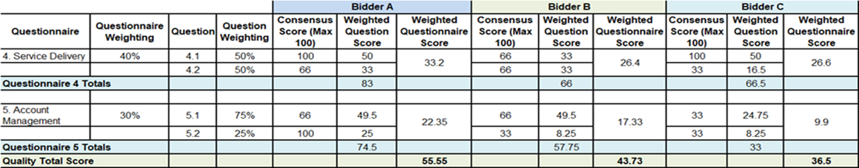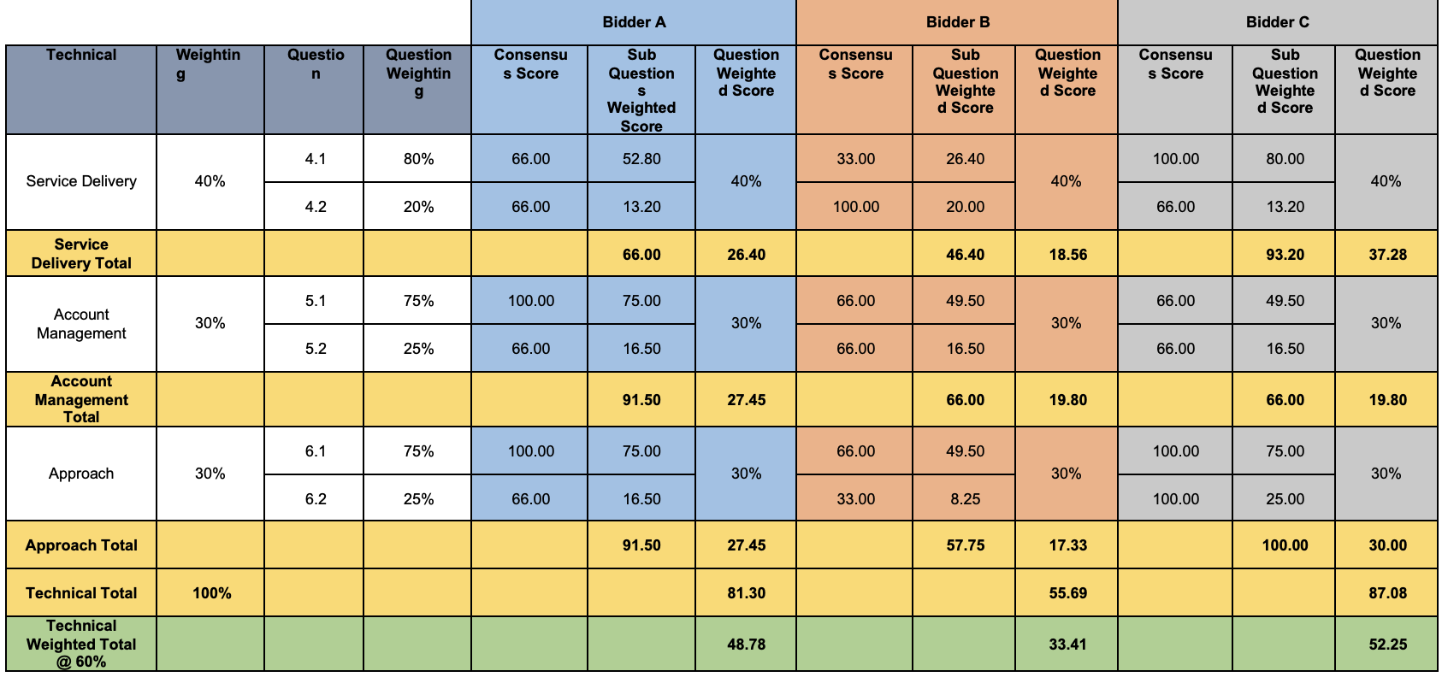

Commercial Evaluation
We will check you have completed the 4. Price Schedule as instructed.
Failure to complete the 4. Price Schedule as instructed may result in your bid being deemed non-compliant and it may be rejected from this competition.
The Bidder with the lowest total price for the 4. Price Schedule will be awarded the maximum score available.
All other Bidders will get a price score relative to the lowest total price.
The calculation we will use to evaluate your total price per element, for each Lot you are bidding for, is as follows:
Price Score = Lowest total price * maximum score available
Bidder’s total price
Please see table B below for an example of how your Price score will be calculated.
Table B – EXAMPLE ONLY
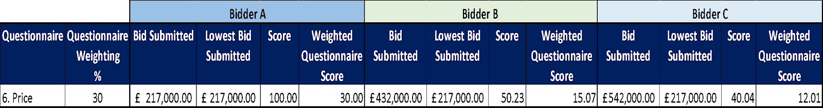
Where we consider any of the total price(s) you have submitted to be abnormally low, we will ask you to explain the price(s) you have submitted (as required in regulation 69 of the Public Contracts Regulations 2015).
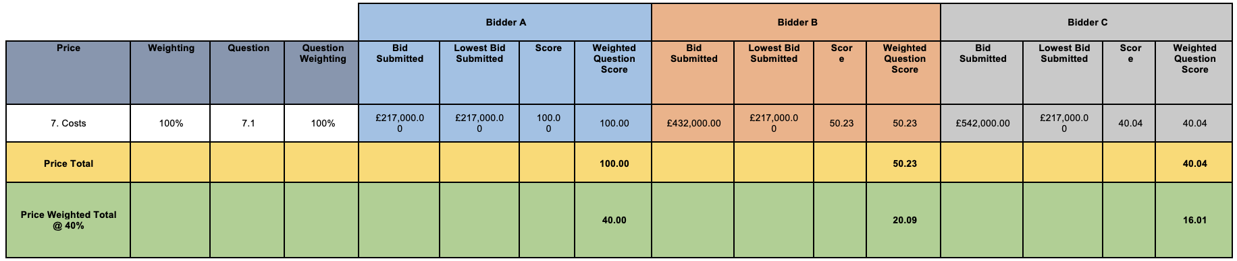

Final Decision to Award
We will add your technical score to your commercial score to calculate your final score.
Please see table C below for an example of how your technical score and price score will be added together to identify your final score.
Where the Final Score achieved by multiple Bidders ranks them in equal position and all such Bidders have achieved the Minimum Pass Mark or higher in all quality questions, the Bidder with the highest score for the highest weighted quality question (i.e. the order of importance), will be deemed the winner and awarded the Contract.
Table C – EXAMPLE ONLY:
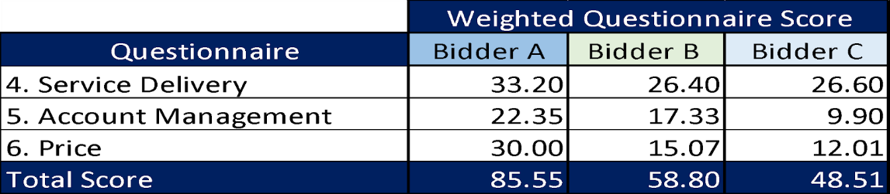
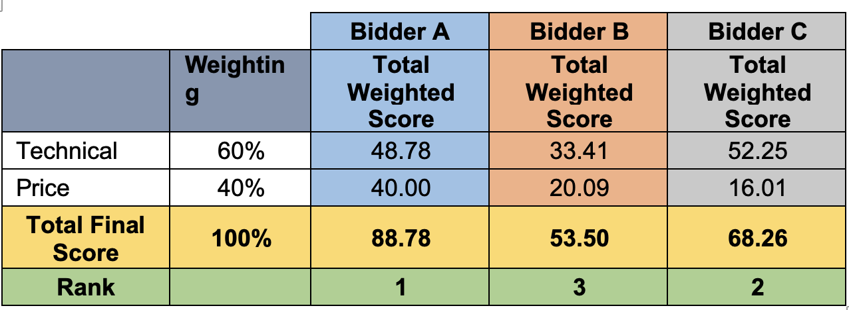

Further Information
All communications will be conducted via the e-sourcing suite, including notification of outcome.

We may include a standstill period in which case the successful bidders will be issued an Intention to Award letter with all suppliers notified of the intended outcome. Please refer to the timetable in Attachment 1 to see if a Standstill is applicable to this procurement. If the 'Standstill Period' and 'Proposed Award Date of Contract' are the same date then a Standstill is not being used. If the dates are different then a Standstill is being used"

If we are using a Standstill we will send Intention to Award letters to all Bidders. At this stage, a Standstill Period of ten (10) calendar days will start, the term Standstill Period is set out in Regulation 87(2) of the Regulations. During this time, you can ask questions that relate to our decision to award.

Following the standstill period, and if there are no challenges to our decision, the successful bidder will be formally awarded a contract.

The conclusion of a contract may be subject to the provision of due ‘certificates, statements and other means of proof’ where Bidders have, to this point, relied on self-certification.

